HTML CSS AND BOOTSTRAP LAB

* You have to create the webpage as given below by adding local files of bootstrap, css and same styling applied as follows:

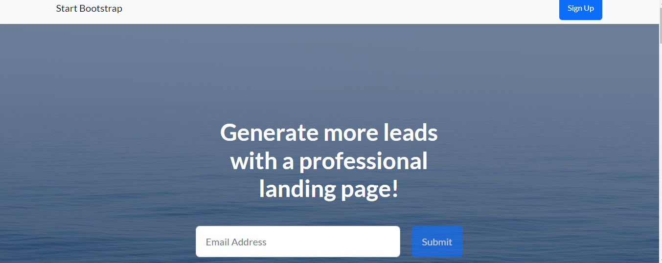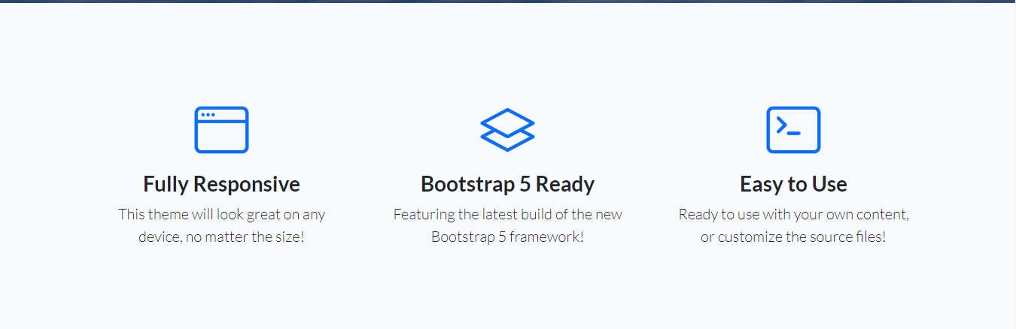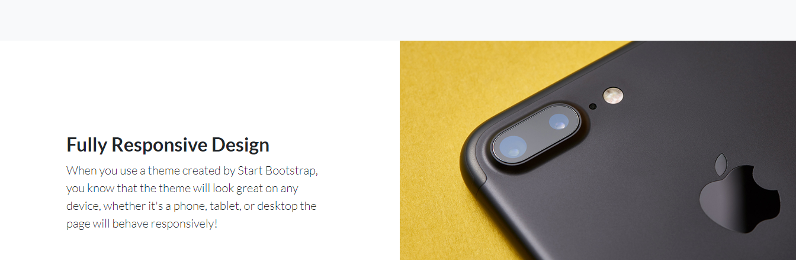

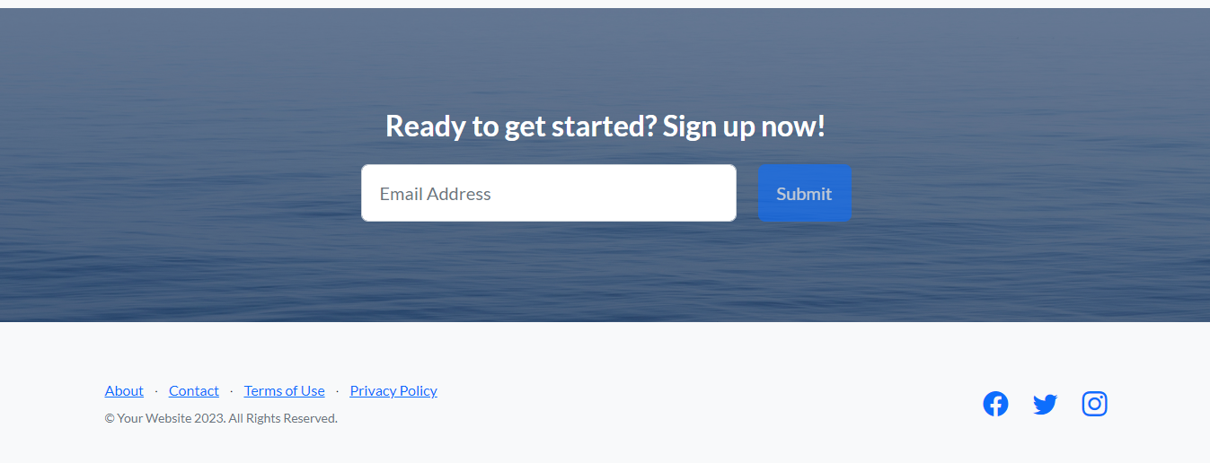

Code:

<!DOCTYPE html>

<html lang="en">

<head>

<meta charset="UTF-8">

<meta name="viewport" content="width=device-width, initial-scale=1.0">

<title>E-Commerce Store</title>

<link rel="stylesheet" href="https://stackpath.bootstrapcdn.com/bootstrap/4.5.2/css/bootstrap.min.css">

<style>

.carousel-item {

opacity: 0;

transition: opacity 0.1s ease-in-out;

}

.carousel-item.active {

opacity: 1;

}

</style>

</head>

<body>

<!-- Navbar -->

<nav class="navbar navbar-expand-lg navbar-dark bg-dark">

<div class="container">

<a class="navbar-brand" href="#">E-Commerce</a>

<button class="navbar-toggler" type="button" data-toggle="collapse" data-target="#navbarSupportedContent" aria-controls="navbarSupportedContent" aria-expanded="false" aria-label="Toggle navigation">

<span class="navbar-toggler-icon"></span>

</button>

<div class="collapse navbar-collapse" id="navbarSupportedContent">

<ul class="navbar-nav ml-auto">

<li class="nav-item active">

<a class="nav-link" href="#">Home</a>

</li>

<li class="nav-item">

<a class="nav-link" href="#">Shop</a>

</li>

<li class="nav-item">

<a class="nav-link" href="#">About</a>

</li>

<li class="nav-item">

<a class="nav-link" href="#">Contact</a>

</li>

</ul>

</div>

</div>

</nav>

<!-- Slider-->

<div id="carouselExampleControls" class="carousel slide" data-ride="carousel">

<div class="carousel-inner">

<div class="carousel-item active">

<img class="d-block w-100" src="slider1.jpg" alt="First slide">

</div>

<div class="carousel-item">

<img class="d-block w-100" src="slider2.jpg" alt="Second slide">

</div>

</div>

<a class="carousel-control-prev" href="#carouselExampleControls" role="button" data-slide="prev">

<span class="carousel-control-prev-icon" aria-hidden="true"></span>

<span class="sr-only">Previous</span>

</a>

<a class="carousel-control-next" href="#carouselExampleControls" role="button" data-slide="next">

<span class="carousel-control-next-icon" aria-hidden="true"></span>

<span class="sr-only">Next</span>

</a>

</div>

<!-- Product Section -->

<div class="container mt-5">

<div class="row">

<div class="col-md-4">

<div class="card">

<img src="applewatch.jpg" class="card-img-top" alt="...">

<div class="card-body">

<h5 class="card-title">Apple Watch Series 9</h5>

<div class="text-center mt-2">

<h5>$599</h5>

</div>

<div class="text-center mt-4">

<a href="#" class="btn btn-dark">Add to Cart</a>

</div>

</div>

</div>

</div>

<div class="col-md-4">

<div class="card">

<img src="airpods.jpeg" class="card-img-top" alt="...">

<div class="card-body">

<h5 class="card-title">AirPods (2nd generation)</h5>

<div class="text-center mt-2">

<h5>$299</h5>

</div>

<div class="text-center mt-4">

<a href="#" class="btn btn-dark">Add to Cart</a>

</div>

</div>

</div>

</div>

<div class="col-md-4">

<div class="card">

<img src="iphone.jpg" class="card-img-top" alt="...">

<div class="card-body">

<h5 class="card-title">iPhone 15 Pro Max</h5>

<div class="text-center mt-2">

<h5>$1299</h5>

</div>

<div class="text-center mt-4">

<a href="#" class="btn btn-dark">Add to Cart</a>

</div>

</div>

</div>

</div>

</div>

</div>

<footer class="bg-dark text-white mt-5">

<div class="container py-3">

<div class="row">

<div class="col-md-6">

<p>&copy; 2024 E-Commerce Store</p>

</div>

<div class="col-md-6 text-right">

<p>Contact: contact@ecommercestore.com</p>

</div>

</div>

</div>

</footer>

<script src="https://code.jquery.com/jquery-3.5.1.slim.min.js"></script>

<script src="https://cdn.jsdelivr.net/npm/@popperjs/core@2.5.4/dist/umd/popper.min.js"></script>

<script src="https://stackpath.bootstrapcdn.com/bootstrap/4.5.2/js/bootstrap.min.js"></script>

</body>

</html>



